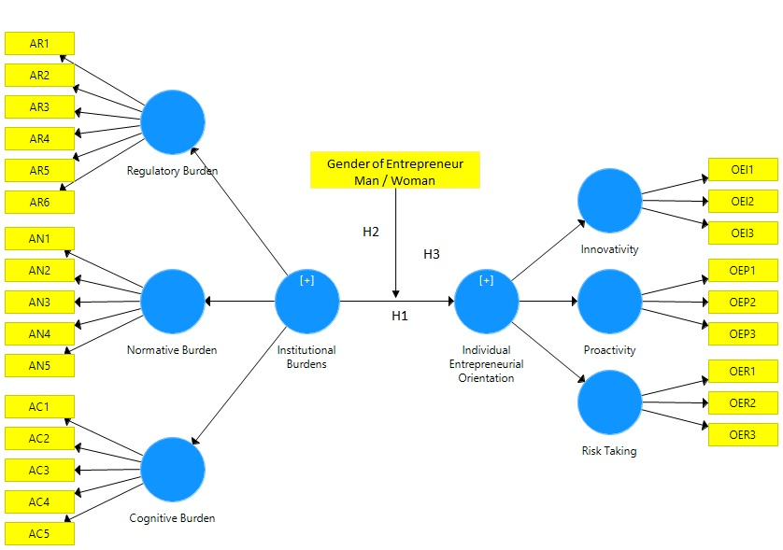
Figure 1. Theoretical model and research hypotheses

Lower Order Constructs  (LOCs) | Indicators | Convergent Validity |  |  |  | Internal Consistency Reliability
 |  | Loadings | Indicator Reliability | t-values | AVE | Composite Reliability | Cronbach’s Alpha
 |  | >0.708 | >0.5 | >2.57 | >0.5 | >0.7 | >0.7
Regulatory Burden | AR1 | 0.791 | 0.626 | 30.177 | 0.631 | 0.895 | 0.854
 | AR2 | 0.774 | 0.599 | 25.972
 | AR4 | 0.789 | 0.622 | 28.234
 | AR5 | 0.818 | 0.669 | 30.920
 | AR6 | 0.800 | 0.640 | 33.358
Normative Burden | AN1 | 0.840 | 0.706 | 28.491 | 0.726 | 0.888 | 0.810
 | AN2 | 0.902 | 0.814 | 82.493
 | AN3 | 0.810 | 0.656 | 31.152
Cognitive  Burden | AC3 | 0.847 | 0.717 | 43.352 | 0.721 | 0.886 | 0.806
 | AC4 | 0.827 | 0.684 | 33.989
 | AC5 | 0.872 | 0.760 | 54.673
Innovativity | OEI1 | 0.908 | 0.824 | 93.358 | 0.819 | 0.900 | 0.779
 | OEI3 | 0.902 | 0.814 | 76.447
Proactivity | OEP1 | 0.818 | 0.669 | 38.486 | 0.697 | 0.874 | 0.783
 | OEP2 | 0.840 | 0.706 | 39.486
 | OEP3 | 0.846 | 0.716 | 42.148
Risk Taking | OER2 | 0.897 | 0.805 | 66.337 | 0.787 | 0.881 | 0.730
 | OER3 | 0.878 | 0.771 | 43.746
Higher Order Constructs  (HOCs) | Construct | Path Coefficients |  | t-values | AVE | Composite Reliability | Cronbach’s Alpha
Institutional  Burdens | Regulatory | 0.938 |  | 111.616 | 0.502 | 0.917 | 0.899
 | Normative | 0.862 |  | 59.977
 | Cognitive | 0.724 |  | 17.491
Individual Entrepreneurial Orientation | Innovativity | 0.808 |  | 33.493 | 0.503 | 0.876 | 0.833
 | Proactivity | 0.890 |  | 54.599
 | Risk Taking | 0.710 |  | 20.926
Source: Own contribution from results obtained with Smart PLS 3. Ringle et al. (2015)

Table 2. Discriminant Validity for the Lower Order Constructs
Lower Order Constructs | Regulatory Burden | Normative Burden | Cognitive Burden | Innovativity | Proactivity | Risk Taking
 | AVE= 0.631 | AVE= 0.726 | AVE= 0.721 | AVE= 0.819 | AVE= 0.697 | AVE= 0.787
Regulatory Burden | 0.794 | 0.891 | 0.645 | 0.336 | 0.418 | 0.451
Normative Burden | 0.748 | 0.852 | 0.533 | 0.334 | 0.383 | 0.495
Cognitive Burden | 0.537 | 0.433 | 0.849 | 0.328 | 0.395 | 0.385
Innovativity | 0.274 | 0.268 | 0.260 | 0.905 | 0.760 | 0.498
Proactivity | 0.342 | 0.308 | 0.314 | 0.593 | 0.835 | 0.599
Risk Taking | 0.355 | 0.381 | 0.294 | 0.378 | 0.454 | 0.887
NOTE: The diagonal numbers (in bold) represent the square root of the AVE values (for reflective constructs). Above the diagonal the HTMT_{.90} correlations ratio Test is presented; below the diagonal, the Fornell-Larcker criterion test is presented.
Source: Own contribution from results obtained with Smart PLS 3. Ringle et al. (2015).

Table 3. Discriminant Validity for the Higher Order Constructs
Higher Order Constructs | Institutional Burdens | Individual Entrepreneurial Orientation
 | AVE= 0.502 | AVE= 0.503
Institutional Burdens | 0.709 | 0.520
Individual Entrepreneurial Orientation | 0.447 | 0.709
NOTE: The diagonal numbers (in bold) represent the square root of the AVE values (for reflective constructs). Above the diagonal the HTMT_{.85} correlations ratio Test is presented; below the diagonal, the Fornell-Larcker criterion test is presented.
Source: Own contribution from results obtained with Smart PLS 3. Ringle et al. (2015).

Table 4. Descriptive statistics of the constructs
Higher Order Construct  . | Variable | Male |  | Female
 |  | Mean | Standard Deviation | Mean | Standard Deviation
Institutional Burdens | Regulative burden | 3.14 | 0.83 | 2.87 | 0.89
 | Normative burden | 3.95 | 0.67 | 3.64 | 0.72
 | Cognitive burden | 3.30 | 0.66 | 3.13 | 0.65
Entrepreneurial Orientation | Innovativity | 3.54 | 0.84 | 3.69 | 0.73
 | Proactivity | 3.61 | 0.76 | 3.67 | 0.67
 | Risk Taking | 3.71 | 0.69 | 3.74 | 0.59

Table 5. PLS-SEM Results of the Structural Model
Hypotheses | Path | Standardized Coefficient β | t-value | $$f^{2}$$ | R²
H₁: The institutional burdens affect significantly the individual entrepreneurial orientation of Aguascalientes City’s micro and small business | Institutional Burdens → Individual Entrepreneurial Orientation | 0.447*** | 9.064 | 0.250 | 0.201
H₂: The institutional burdens affect significantly the individual entrepreneurial orientation of Aguascalientes City’s micro and small business created by man. | Institutional Burdens by man entrepreneur → Individual Entrepreneurial Orientation | 0.515*** | 8.596 | 0.361 | 0.265
H₃: The institutional burdens affect significantly the individual entrepreneurial orientation of Aguascalientes City’s micro and small business created by woman. | Institutional Burdens by woman entrepreneur → Individual Entrepreneurial Orientation | 0.340*** | 3.958 | 0.131 | 0.116
Significance: *** = p<0.001; ** = p<0.05
$f^{2}$ effect sizes: >0.02= Small effect; >0.15 = Medium effect; >0.35 Large effect (Cohen, 1988).
R² values: >0.20 = Weak; >0.33 Moderate; >0.67 = Substantial (Chin, 1998).

Source: Own contribution from results obtained with Smart PLS 3. Ringle et al. (2015).

Table 6. PLS-Multigroup Analysis
Path | Path Coefficient  Group: Man | Path Coefficient  Group: Woman | Path Coefficient  Difference | p-value  Man vs Woman
Institutional Burdens → Individual Entrepreneurial Orientation | 0.515*** | 0.340*** | 0.175** | 0.046
Significance: *** p<0.001; **p<0.05
Source: Own contribution from results obtained with Smart PLS 3. Ringle et al. (2015).

